

FACULTY OF INFORMATION AND COMMUNICATION TECHNOLOGY

PROG 102 : IPRINCIPLES OF SOFTWARE ENGINEERING

Title: SOFTWARE DESIGN FOR A DIGITAL PUBLIC GOOD

Due date: Week 11

Semester/Year: 2\1

Class: BIT1201F

Lecturer: Mr. Mohamed Lamin Kamara

Group: Group 8

Academic Honesty Policy Statement
We, hereby attest that contents of this attachment are our own work. Referenced works, articles, art, programs, papers, or parts thereof are acknowledged at the end of this paper. This includes data excerpted from CD-ROMs, the Internet, other private networks, and other people’s disks of the computer system.

Student’s Signature: Date:

NO | NAME SURNAME SIGN ID
1 | PETER VANDI BASSIE |  | 905006490
2 | HENRY MELVIN MANNING |  | 905006153
3 | MARIAMA FATMATA FOFANAH |  | 905005741

LECTURER’S COMMMENTS/GRADE: | for office use only upon receive  Remark  DATE :  TIME :  RECEVER’S NAME:

TABLE OF CONTENT

1. Project Overview and SDG Alignment
Focus: Digital Public Good standards & UN SDG 8 alignment

2. Software Development Life Cycle (SDLC) Implementation
Focus: Weekly progression breakdown from Week 1 to Week 11

3. System Architecture Design
Diagram: 3-Tier Architecture System Diagram

3.1 Use Case Analysis (with Use Case Diagram)

3.2 Process Workflow (with UML Activity Diagram)

4. Prototype Development (UI/UX Design)
Focus: Functional analysis of the 10 core Figma screens

5. Git and GitHub Integration
Focus: Version control & Documentation-as-Code workflow

- Project Management: Timeline and Logic

  - Project Schedule (with Gantt Chart)

  - Network Logic (with PERT/CPM Network Diagram)

- Licensing and Quality Assurance

Focus: MIT License framework & UI/UX design standards

- Conclusion

- References
WORKLINK SL: DIGITAL PUBLIC GOOD PROJECT DOCUMENTATION REPORT

- Project Overview and SDG Alignment
WorkLink SL is conceptualized as a robust piece of distributed digital infrastructure designed specifically to navigate the unique labor market complexities of Sierra Leone. Developed within the academic framework of the Faculty of Information and Communication Technology at Limkokwing University of Creative Technology, this platform is engineered as a Digital Public Good (DPG). It adheres to essential DPG standards, including the use of open-source standards and architectural interoperability, to ensure vendor lock-in avoidance and long-term sustainability for the Sierra Leonean government and its citizens.

The project is strategically aligned with United Nations Sustainable Development Goal (SDG) 8: Decent Work and Economic Growth. By bridging the systemic gap between local talent and professional opportunities, WorkLink SL facilitates a transparent, data-driven recruitment ecosystem. This digital solution provides transformative value by mitigating information asymmetry, empowering job seekers with keyword-based querying tools, and providing employers with a streamlined pipeline to secure skilled human capital, ultimately driving national economic expansion.

2. Software Development Life Cycle (SDLC) Implementation
The development of WorkLink SL utilizes a structured SDLC methodology, meticulously tracked via project management tools to ensure high-fidelity delivery within the constraints of the academic semester.

- SDLC Planning (Weeks 1-2): This phase involved comprehensive requirement elicitation and the definition of the DPG conceptual framework. Activities focused on identifying the socioeconomic requirements of the Sierra Leonean labor market and ensuring the system's foundational goals aligned with international DPG standards.
- System Architecture & UML Design (Weeks 3-4): Technical modeling was prioritized during this stage. Using Unified Modeling Language (UML), the structural framework was established, defining actor roles and system boundaries to ensure a scalable and secure backend-to-frontend relationship.
- Prototype Development (Weeks 5-8): Transitioning to UI/UX design, this phase utilized Figma to construct a 10-screen functional prototype. The focus remained on creating an intuitive user experience that simplifies complex job-matching logic into an accessible mobile interface.
- Git & GitHub Integration (Weeks 5-6): Executed in parallel with prototyping, this phase implemented a "Documentation-as-Code" workflow. By establishing a centralized repository, the team ensured version control for all design assets and technical reports, maintaining a rigorous audit trail of project iterations.
- Project Management & Testing (Weeks 9-10): This phase focused on quality assurance and schedule adherence. The project was audited against the initial Gantt chart to ensure all functional requirements were met and that the system logic remained consistent with the defined state transition logic.
- Final Documentation & Submission (Week 11): In strict adherence to the project deadline provided by Limkokwing University, the final phase concludes in Week 11. This involved the synthesis of all architectural diagrams, prototype links, and technical specifications into this comprehensive final report.

3. System Architecture Design
The WorkLink SL architecture is designed to support a high volume of concurrent interactions while maintaining data integrity through clear logical separation.

Component Interaction: The system architecture relies on a request-response model in which the frontend user interface communicates asynchronously with the backend database. When a Job Seeker initiates a search, the frontend sends a keyword-based query to the server, which filters the database and returns a structured dataset. This separation of concerns ensures that the user experience remains responsive regardless of backend processing loads.

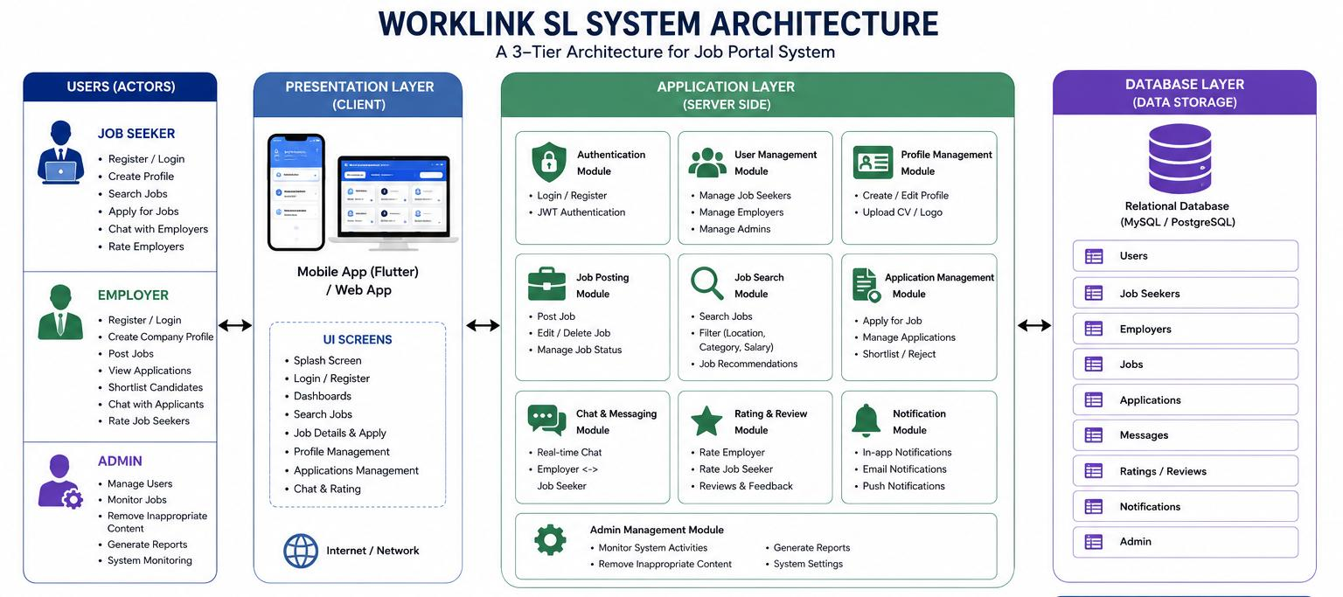

3.1 Use Case Analysis: The Use Case Diagram defines the interactions between the system and three primary actors: the Job Seeker, the Employer, and the Admin. The platform facilitates six core functional interactions:

- Register/Login: Secure credential-based access for all users.
- Search Jobs: Job seekers query the distributed database for active vacancies.
- Post Jobs: Employers input role specifications into the system.
- View Jobs/Details: A detailed display of job metadata and requirements.
- System Maintenance/User Management: An administrative function reserved for the Admin actor to ensure platform stability and moderate user data.
- Delete Accounts: A critical function for data privacy and user autonomy.

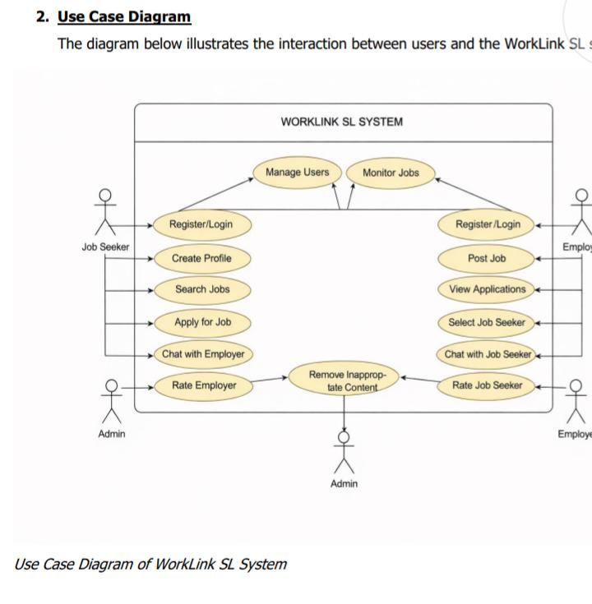

3.2 Process Workflow The UML Activity Diagram: Job Search and Application illustrates the state transition logic for a Job Seeker:
- The process begins when the Job Seeker logs in.
- The user enters the Search for Jobs state.
- The system evaluates the "Jobs Found?" decision node.
- If the condition is "No," the user is directed to Refine Search, returning to the search input state.
- If the condition is "Yes," the user proceeds to View Job Details.
- The user selects the Apply for Job action.
- The sequence concludes when the Employer receives notification of the transaction.

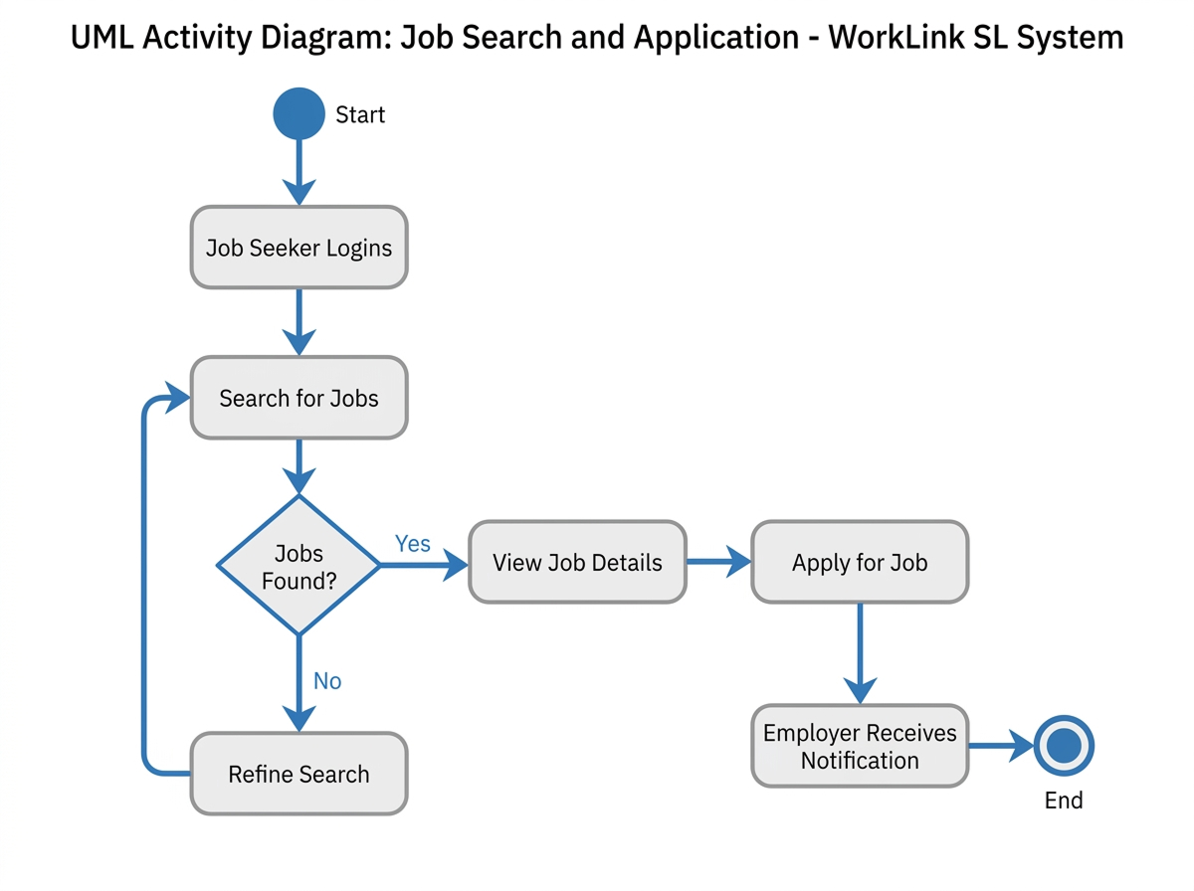

4. PROTOTYPE DEVELOPMENT (UI/UX DESIGN)
The WorkLink SL prototype consists of 10 key screens designed in Figma, focusing on a minimalist aesthetic to minimize cognitive load for users.

Welcome/Onboarding Screen
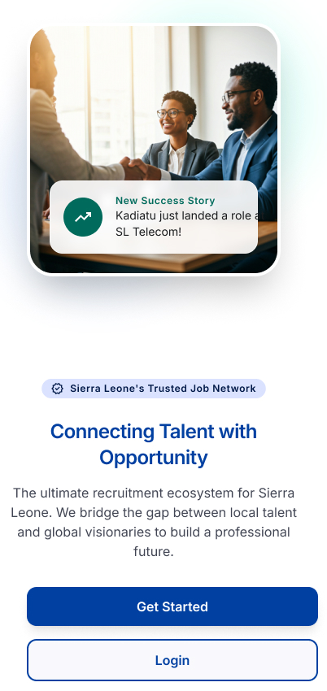

Login/Access Screen
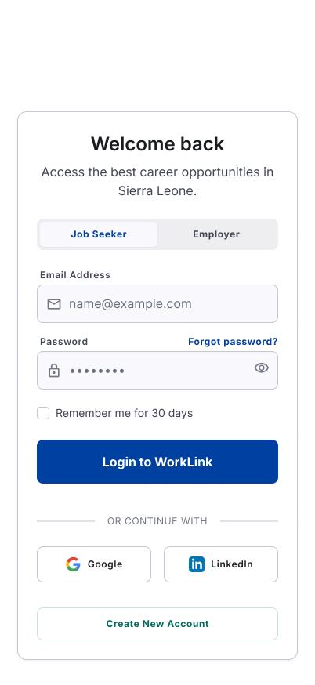
Job Seeker Dashboard

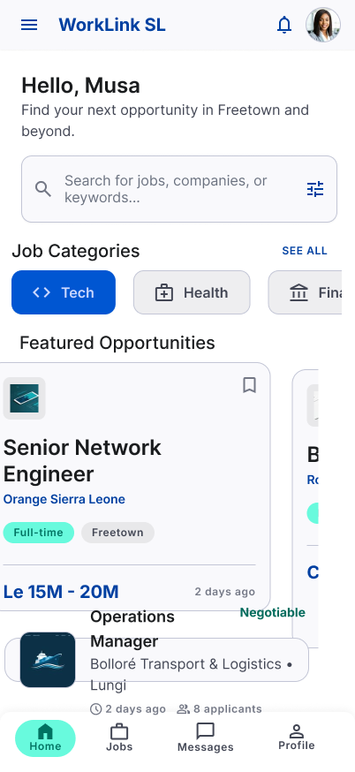

User Profile Management

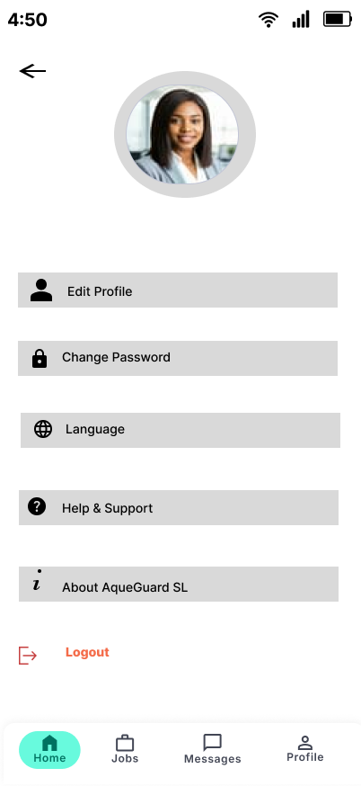

Search & Filter Interface

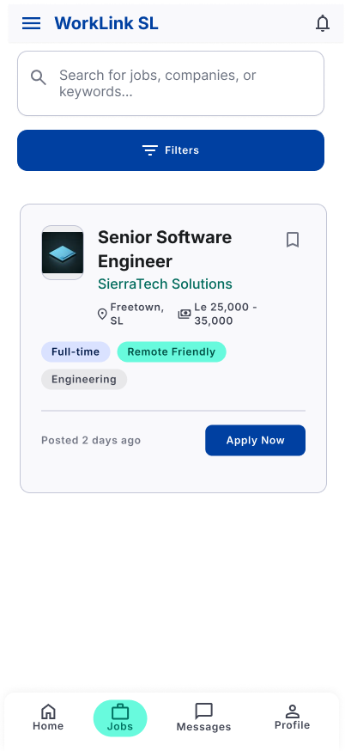

Job Details View

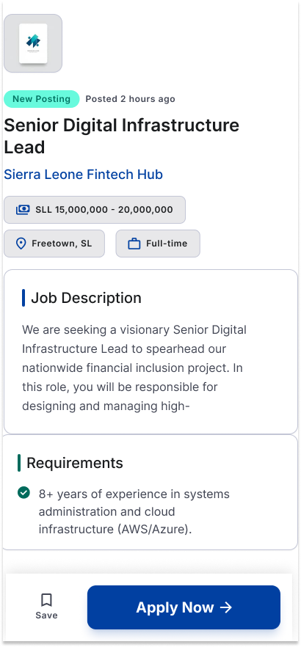

Employer Dashboard
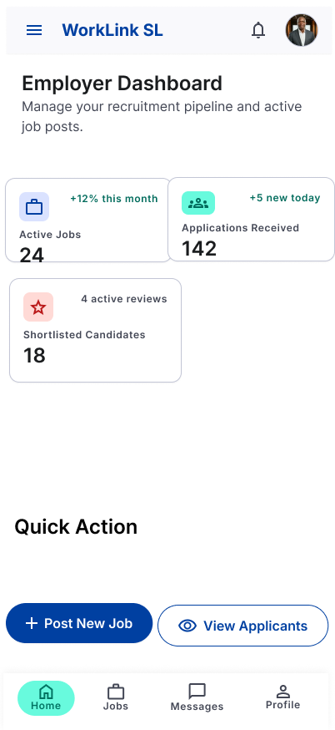

Job Posting Interface
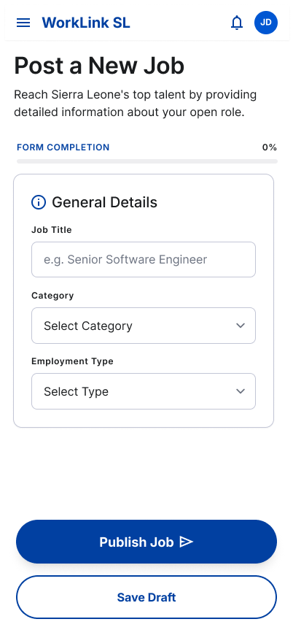

Interview Scheduling/Management

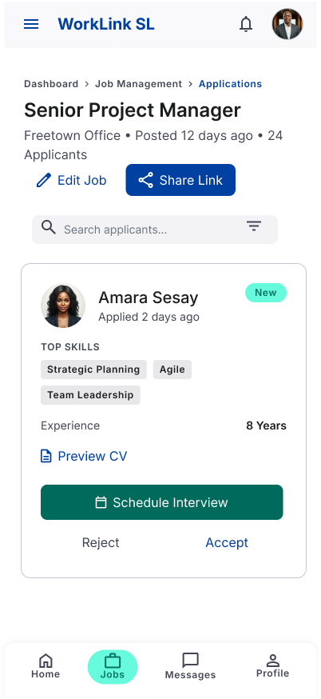

Navigation/Menu System

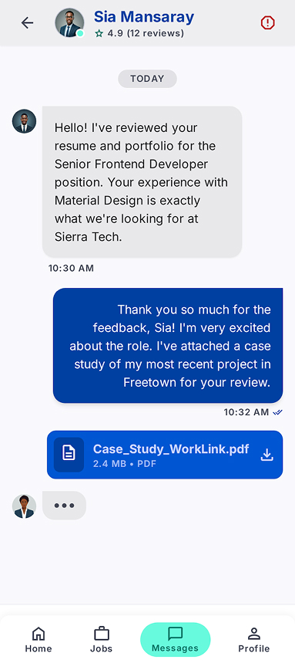

- Welcome/Onboarding Screen: A high-impact entry point focused on "Connecting Talent with Opportunity."
- Login/Access Screen: A secure portal providing distinct authentication paths for different user roles.
- Job Seeker Dashboard: A centralized hub featuring real-time job categories (e.g., Tech, Health) and featured opportunities.
- User Profile Management: Allows for granular control over personal data and security settings, including "Change Password."
- Search & Filter Interface: Employs real-time filtering and keyword-based querying to allow users to isolate roles by company or title.
- Job Details View: Displays the full role profile for positions such as "Senior Digital Infrastructure Lead," featuring a prominent "Apply Now" Call-to-Action (CTA).
- Employer Dashboard: A recruitment analytics view showing "Active Jobs" and "Applications Received" (e.g., tracking the 142 total applications received).
- Job Posting Interface: A standardized form for employers to define "General Details" and industrial categories for new listings.
- Interview Scheduling/Management: A status-management interface allowing employers to "Schedule Interview," "Reject," or "Accept" candidates like Amina Sesay.
- Navigation/Menu System: A persistent bottom navigation bar ensuring seamless transitions between Messages, Jobs, and Profile settings.

5. Git and GitHub Integration
GitHub serves as the foundational repository for the WorkLink SL project, facilitating a "Documentation-as-Code" environment. This centralized hub is utilized for version-controlled storage of UML diagrams, prototype links, and technical reports. By leveraging Git, the project maintains high integrity; every modification is tracked, ensuring that design assets and documentation are protected against data loss. This collaborative environment allows for a synchronized workflow, essential for maintaining the project's rigorous development timeline.

6. Project Management: Timeline and Logic
Effective project management was essential to ensure all deliverables were finalized before the Week 11 submission deadline at Limkokwing University.
6.1 Project Schedule (Gantt Chart) The following table outlines the project lifecycle from the issuance of the project brief in Week 4 to the final submission.

Task Name | Start Week | End Week
System Architecture & UML Design | Week 4 | Week 4
Prototype Development | Week 5 | Week 8
Git & GitHub Integration | Week 5 | Week 6
Project Management & Testing | Week 9 | Week 10
Final Documentation & Submission | Week 11 | Week 11

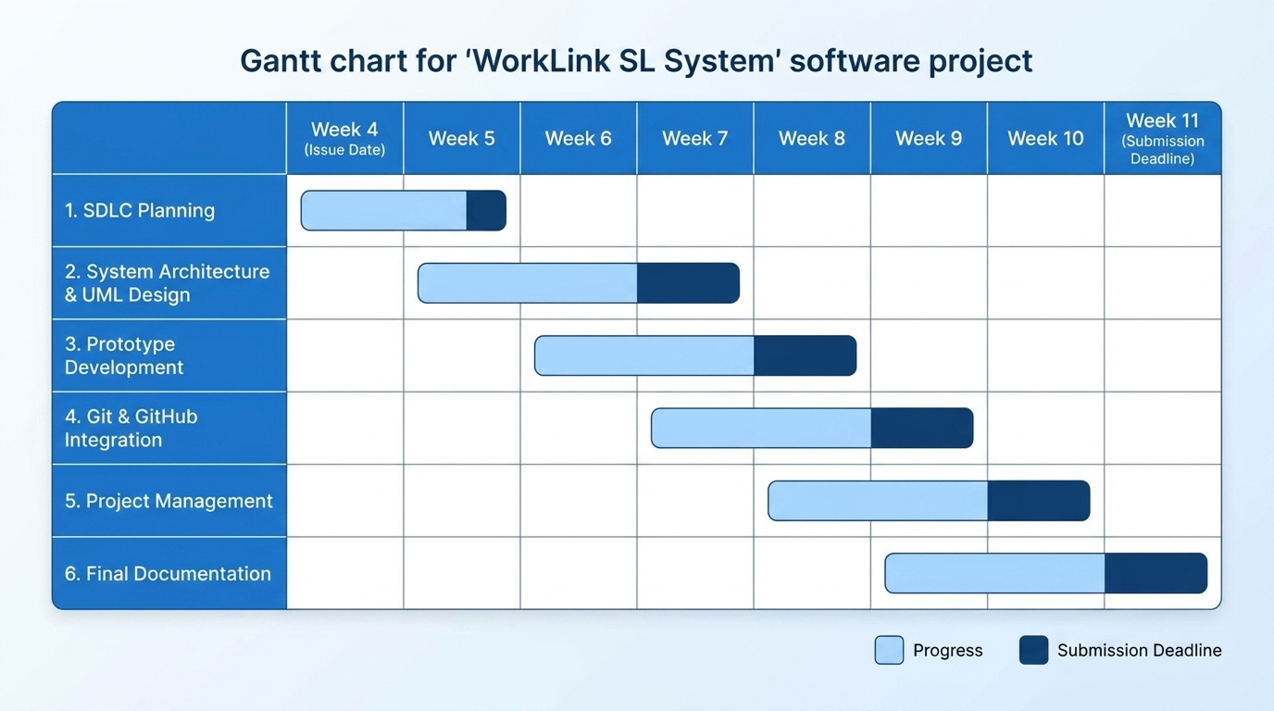

6.2 Network Logic (PERT/CPM) The Network Diagram identifies the critical path and highlights the strategic use of parallel development. Between Weeks 5 and 6, "Prototype Development" and "Git Integration" were conducted simultaneously. This overlap allowed the design team to build the UI/UX while the technical lead established the version control environment, effectively compressing the schedule and ensuring that the Project Management and
Testing phase could begin without delay in Week 9.

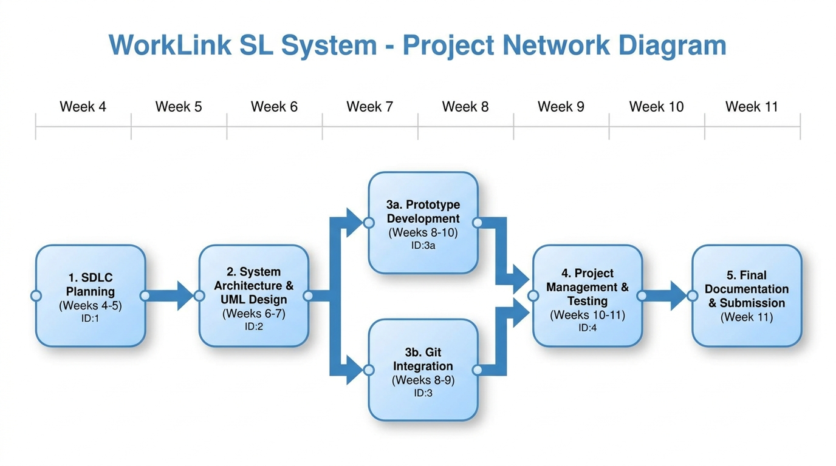

7. Licensing and Quality Assurance
To maintain its status as a Digital Public Good, WorkLink SL is released under the MIT License. This open-source license ensures that the software remains accessible, allowing for community-driven improvements and transparent usage rights while requiring proper attribution.

Design Quality (UI/UX): The UI/UX design adheres to modern engineering standards of cleanliness and consistency. By utilizing a uniform typography (Tahoma) and consistent iconography across all 10 Figma screens, the platform provides an intuitive navigation experience that reduces user friction.

8. Conclusion
WorkLink SL stands as a comprehensive, ready-to-deploy digital infrastructure solution tailored to address the structural complexities of the Sierra Leonean labor market. By combining a structured Software Development Life Cycle (SDLC) methodology with the design of a 10-screen high-fidelity Figma prototype, the system simplifies complex job-matching logic into an accessible mobile interface.

The technical execution achieves academic and industry rigor through several key pillars:
- Ecosystem Integrity: Unified Modeling Language (UML) structural designs and clear 3-tier architecture separating concerns ensure long-term database stability.
- Project Management Rigor: Clear parallel scheduling workflows using Git and GitHub effectively compressed timeline dependencies between development phases.
- Socioeconomic Impact: Grounding the platform in United Nations Sustainable Development Goal 8 (SDG 8) and Digital Public Goods (DPG) open standards prevents vendor lock-in and aligns directly with national development objectives.

Deployed under the open-source MIT License, WorkLink SL successfully satisfies all functional specifications and academic criteria, delivering a viable, scale-ready ecosystem framework to drive employment connectivity and national economic growth.

REFERENCES

Digital Public Goods Alliance (2021). The Digital Public Goods Standard, Version 1.2.1. Available at: https://digitalpublicgoods.net/standard/ [Accessed: 18 June 2026].

Figma (2026). Figma Design Systems & Interface Prototyping Software. San Francisco: Figma Inc. Available at: https://www.figma.com [Accessed: 18 June 2026].

GitHub, Inc. (2026). GitHub Repository Hosting Service and Documentation-as-Code Workflows. Available at: https://github.com [Accessed: 18 June 2026].

Massachusetts Institute of Technology (2006). The MIT License. Open Source Initiative. Available at:https://opensource.org/licenses/MIT [Accessed: 18 June 2026].

